**MEMORANDUM**

From: Cody Turpin

To: Dr. Craig

Date: 5/10/21

Subj: Does temperature influence economic output?

**EXECUTIVE SUMMARY**

This paper looks tries to find the answer to the reason why, typically, hotter countries have a lower GDP/capita than colder countries. First, the paper looks at the impact that temperature and factors that relate to it has on an economy’s GDP/capita. The first part compares temperature to GDP/capita which finds that temperature does play a statistically significant factor in GDP/capita, which is coincided with the latitude of a country’s capital city. Surprisingly, temperature makes up quite a bit of GDP/capita at around 12%, which is a lot compared to all of the other factors involved with GDP/capita. In the second part there is a comparison between average hours of sunlight and GDP/capita, which found that it has an even more statistically significant impact on GDP/capita than temperature. All of this put together concludes that temperature does appear to have a significant impact on economic output.

**PART 1: Comparing Temperature to GDP/Capita**

The first question was how impactful temperatures were to economy. This was done by collecting data and then comparing a nation’s gross domestic product (GDP) per person (per capita) to the average temperature found in that nation. The thesis behind this was that as temperatures rose, GDP/capita would decrease as it appears to be that colder countries happen to have much larger economies. Countries like the United States, Canada, Norway, and even Australia are all very rich, and cold countries, especially compared to countries like Mexico, Iraq, Mali, Colombia, and Laos which are all poor, and warm, countries. Even within countries like the United States it appears that the colder and more northern states have overall prospered more economically per person than have the warmer southern states. In Australia, Sydney and Melbourne, which are down south in the cooler weather, are the richest cities in the country meanwhile Darvin, up in the hot north, is one of the poorest cities in the country even though it is geographically in the best position to be a major trading port for the rest of Asia. Latitude was also included in this this comparison to have as a factor to add comparison between temperature and distance from the equator.

***How this data was collected:***

To begin researching into this question data had to be collected. For the comparison between temperatures and GDP/capita data was obtained from a few sources. GDP per capita and the nation’s region was collected from WorldBank.org and the average temperatures were collected from Statpedia, one of the few sources that had taken the time to calculate and determine a good average temperature per nation. This data was compared to other sources such as ClimatesToTravel.com and a couple Google Searches that gave one or two cities within each of those countries and their mean temperatures (taken by adding the min and max temps for each city and dividing by two) and comparing that number to the ones from Statpedia. This tedious process was done for every country to ensure accuracy and the averages between the cities and that from Statpedia was rather accurate with average temperatures rarely with a difference more than 5-degrees Fahrenheit. Latitude for the capitals was from LM Nixon and supported by a Google search.

***Running the Numbers:***

As expected, temperature and latitude line up with each other in the first scatter plot with capital cities that are further away from the equator being within a country that is colder and those that are closer to 0 are in countries with warmer temperatures. The R-Sq value is also rather high as expected between latitude and temperature at 41.5%, meaning that 41.5% of a city’s temperature is determined by its latitude. There is a downward sloping relationship which is due to the fact that there are just a larger number of capitals in the Northern Hemisphere because the North typically has a lot of smaller countries geographically.

When latitude is compared to GDP/capita, an interesting relationship is found between the two. The further away from 0 the latitude gets, the more dispersed and the higher the GDP/capita becomes, whereas countries with a latitude in their capital city closer to 0 have a very low GDP/capita and almost all have the same GDP/capita at least within a couple thousand dollars. The R-Sq for this comparison is 14.2% which might seem small but is really significant when compared to all of the other factors that actually make up a nation’s economic output such as culture and infrastructure and government and stability.

Since latitude and temperature are closely related by the fact that latitude explains 41.5% of temperature, the relationship between average temperature and GDP/capita results a in a negative relationship. The graph shows that as temperature increases, GDP/capita decreases which follows our hypothesis that countries in warmer climates have less economic output per person. The R-Sq for this relationship is similar to that of latitude and GDP/capita at 12.7%. Again, although that does not seem very significant this is simply the temperature affecting an entire nation’s economic output, which on the surface is surprising how impactful temperature truly is alongside so many other causes for economic output.

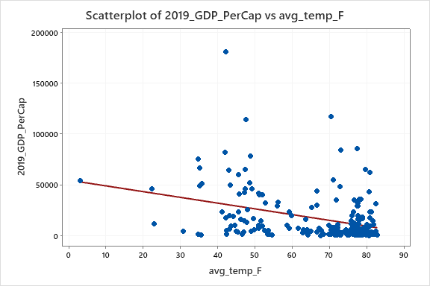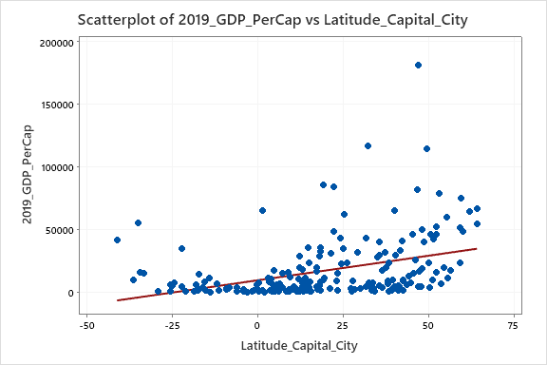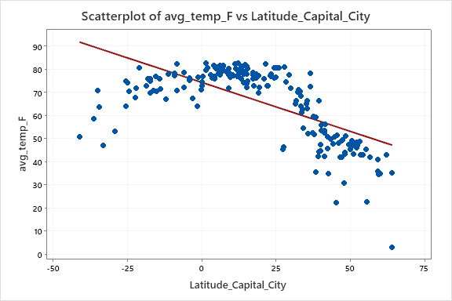

***Results of part 1:***

When a fit regression model is run with both latitude and temperature compared to GDP/capita it reveals that both are significant factors to influence economic output because both have a p-value from this test below 5%, with latitude at 0.3% and temperature at 2.1%. The R-Sq value of the two variables together is 16.39%, which is quite impressive given that it is only temperature and latitude.

There are numerous reasons that we can begin to think about as to why temperature would have a significant impact on GDP/capita. Perhaps those living in warmer climates over generations had it easier overall because farming was easier and more prosperous, homes did not have to be as complex to weather against harsh cold temperatures and resources are typically plentiful for human life. In colder climates however, conditions are typically harsher requiring people to store food throughout winter and build complex homes to keep them warm and have to develop numerous innovations to simply survive. Of course, as history shows, the people who lived in warmer climates were typically well off and richer due to their abundance of resources and naturally calm living conditions. But in the modern day, where innovation and technological advancements are more valuable than agriculture, the colder climates who had to innovate early on kept innovating and as their new technologies became more advanced so did the economic output of those nations as they were more capable of developing better processes to increase output.

When an ANOVA test was done with Tukey comparison between average temperature and income group it becomes clear that high income countries are significantly different than “low,” “low-middle,” and “upper-middle” income groups, being grouped separately than the others. The high-income group also is lower in temperature, supporting our hypothesis that colder countries are richer. In addition to this, when comparing the other three groups, although they are all close enough to not be significantly different from each other there is still a noticeable downward trend where the wealthier countries are typically colder which is even more support for our hypothesis.

The problem is that, as expected, temperature is not a huge factor overall in GDP/capita because there are just so many other parts to economic productivity, but the fact that there is significance is impressive. Digging further came the realization that, when temperature was compared to other related factor, its significance decreases significantly, but this reveals a more surprising factor to economic output: average hours of sunlight per day, which has a p-value of 4.5% making it a significant factor; even more so than how many filings there are for intelligent property (ranking of IP filing). An important note to make is that all of these factors together have an R-Sq of 23.39% (19.86% excluding Rank of IP filing), meaning that seemingly obscure factors to the economy like temperature, precipitation, hours of sunlight, and latitude, all have quite an impact on the economic output of a country.

**Coefficients**

|  |  |  |  |  |  |
| --- | --- | --- | --- | --- | --- |
| **Term** | **Coef** | **SE Coef** | **T-Value** | **P-Value** | **VIF** |
| Constant | 32715 | 10158 | 3.22 | 0.001 |  |
| avg_temp_F | -310 | 134 | -2.32 | 0.021 | 1.71 |
| Latitude_Capital_City | 260.8 | 87.9 | 2.97 | 0.003 | 1.71 |

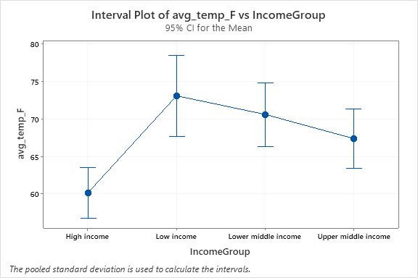

**Coefficients**

|  |  |  |  |  |  |
| --- | --- | --- | --- | --- | --- |
| **Term** | **Coef** | **SE Coef** | **T-Value** | **P-Value** | **VIF** |
| Constant | 72911 | 19188 | 3.80 | 0.000 |  |
| avg_temp_F | -79 | 296 | -0.27 | 0.791 | 3.20 |
| avg_precip_in | -52 | 118 | -0.44 | 0.658 | 2.30 |
| avg_sunshine_hrs | -5579 | 2749 | -2.03 | 0.045 | 3.39 |
| Ranking_Of_IP_Filing | -167 | 103 | -1.62 | 0.109 | 1.37 |
| Latitude_Capital_City | 52 | 152 | 0.34 | 0.734 | 1.93 |

**PART 2: How Impactful is the Average Number of Hours of Sunlight to GDP/Capita**

The surprising finding that the average number of hours of sunlight is so significant requires more research to determine how impactful it is to GDP/capita and what it contributes to. The natural inkling is that more hours of sunlight should result in a higher GDP/capita because people will feel like they have more time in the day to be productive and work and should result in more output. But from the scatter plot above that compared GDP/capita to latitude of capital cities this might not be the case as those countries closer to the equator (which should receive more sunlight hours per day on average) have a lower GDP/capita than those further away (which should receive less sunlight hours/day). There are likely several factors that are derived from the amount of sunlight a country receives including temperature that could make this factor better at describing the variation in climates and economic output.

***How this data was collected:***

The average number of sunlight hours per day that a country receives came from ClimatesToTravel.com, which gave the average sunlight hours per day for specific cities within each country. Although this was with specific cities and might not be representative of an entire country, especially longer countries like Chile, the standard deviation for sunlight hours is 1.65 and with that standard deviation equating to thousands of miles vertically only a handful of countries would have a significant variation from north to south. It’s safe to conclude that this number is relatively accurate within an hour.

***Running the Numbers:***

The first graph shows a scatterplot comparing average temperature and average sunlight hours per day with a positive correlation, as expected. The R-Sq of this comparison is 25.5%, depicting a rather strong relationship between the two, that the number of hours of sunlight exposure is a significant factor in the temperature of a country which makes sense given that the Earth gets its heat from the sun. There is a bit of a gap though between 5 and 7 hours and around 55 to 70 degrees, which could be caused by other unknown factors. When a scatterplot was run between sunlight hours and latitude there was no gap, so something else must be affecting temperature which is the other 74.5% of factors.

When a scatterplot was run between GDP/capita and average sunlight per day there was a negative correlation between the two, as sunlight hours per day increased the GDP/capita decreased. This has an R-Sq of 11.57% which, like the relationship between GDP/capita and temperature, does not seem all that significant at first except for the fact that there are so many economic factors that average hours of sunlight per day impacting GDP/capita by 11.5% is rather significant. In addition to this, when a linear regression analysis is done, alongside ranking_of_IP_filing which was the second lowest p-value on the regression with all of the variables, it has a p-value of 0.1% which is less than 5% making it a statistically significant to GDP/capita.

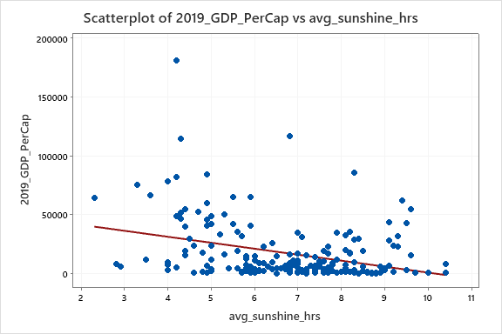

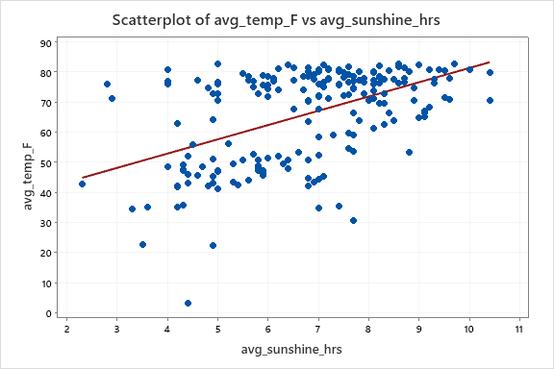

**Coefficients**

|  |  |  |  |  |  |
| --- | --- | --- | --- | --- | --- |
| **Term** | **Coef** | **SE Coef** | **T-Value** | **P-Value** | **VIF** |
| Constant | 70359 | 9791 | 7.19 | 0.000 |  |
| avg_sunshine_hrs | -5819 | 1647 | -3.53 | 0.001 | 1.24 |
| Ranking_Of_IP_Filing | -190.1 | 97.3 | -1.95 | 0.054 | 1.24 |

**CONCLUSION**

There are several factors that all make up a country’s GDP/capita and it appears that temperature and its related factors have a statistically significant impact based on the results of the tests. There are several reasons for the impact that temperature has, as well as with the number of hours of sunlight a place gets in a day. It would be expected that the more hours of sunlight in a day would result in more productivity since people would have more daylight to have a sense of being productive. This likely is not the case though given that the more daylight per day typically results in less GDP/capita. The negative relationship between temperature and daylight hours to GDP/capita has numerous possibilities that can be speculated as to why such a relationship exists. One possibility is that countries with warmer weather and more sunlight hours per day have an economic advantage to be more agricultural rather than focus on technologies and innovation. The possibility of technological advancements being forced upon colder climates, as mentioned before, is also a possibility. These are all possibilities that could have caused a significant difference between GDP/capita and temperature and sunlight, which is still impressive compared to the numerous factors that make up economic output and GDP/capita. We can conclude that temperature and its related factors have a statistically significant impact on GDP/capita.

**REFERENCES:**

“Average Yearly Temperature by Country (1961 – 1990),” ***Statpedia***, https://statpedia.com/stat/Average_Yearly_Temperature_by_Country/HJd7OcGK.

Cecchini, Pegasusweb. “World Climate Guide,” ***Climates to Travel***, https://www.climatestotravel.com/.

“GDP Per Capita Worldwide,” ***World Bank***, https://data.worldbank.org/indicator/NY.GDP.PCAP.CD.

“Latitude and Longitude of World Capital Cities,” ***LM Nixon***, https://lab.lmnixon.org/4th/worldcapitals.html.

“World Intellectual Property Indicators 2019,” ***World Intellectual Property Organization***, p. 10 table 1, https://www.wipo.int/edocs/pubdocs/en/wipo_pub_941_2019.pdf.